Problem Statement 3: Shopping Cart for a Bookstorecontinued –Inserting the required data into tables

1.Books Table

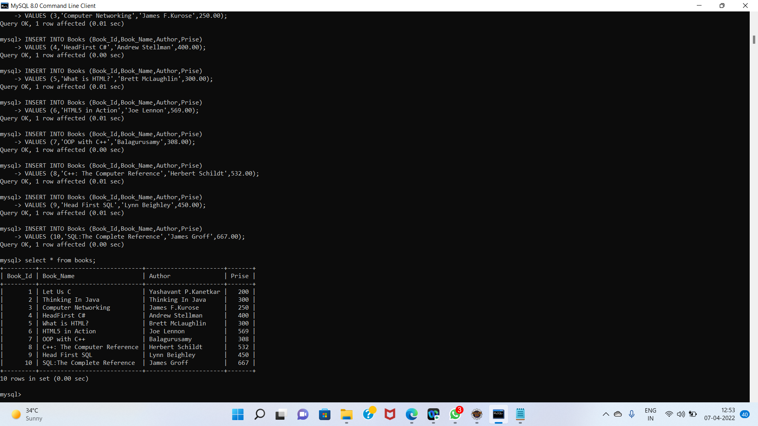

2.Users Table

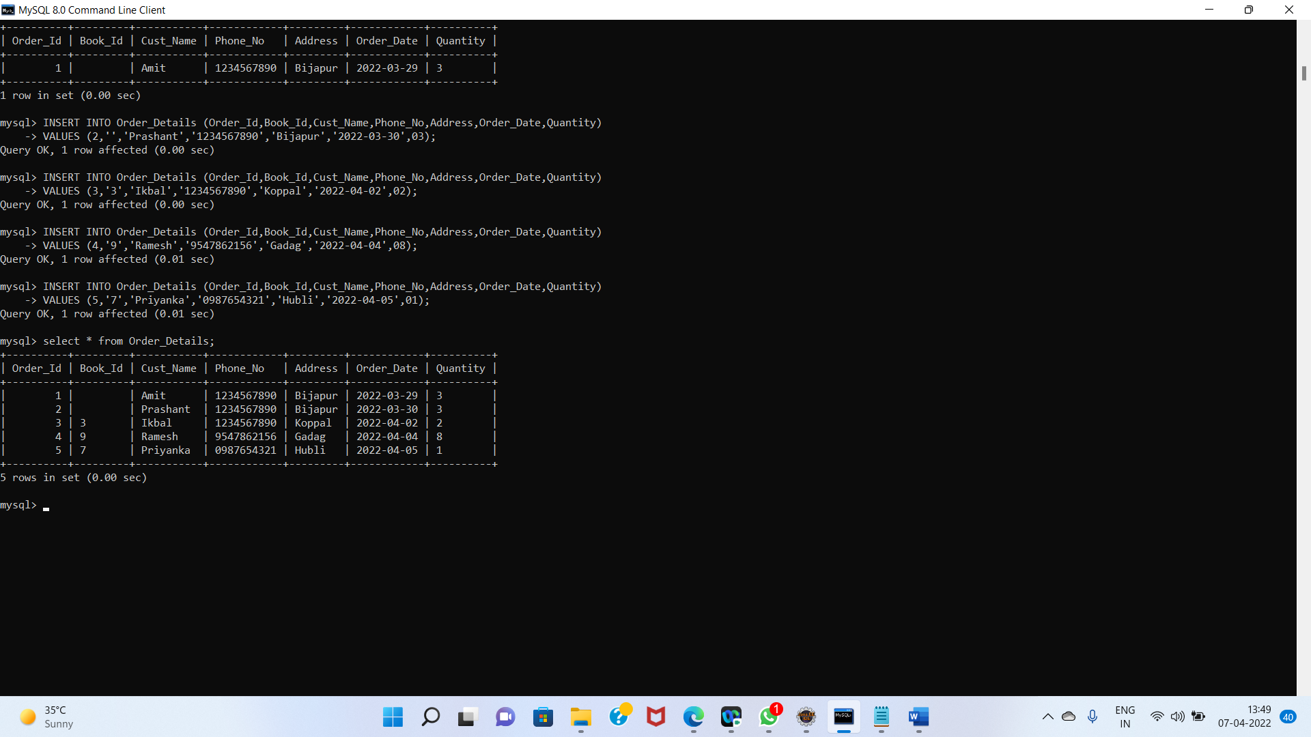

3.Order_Details Table

